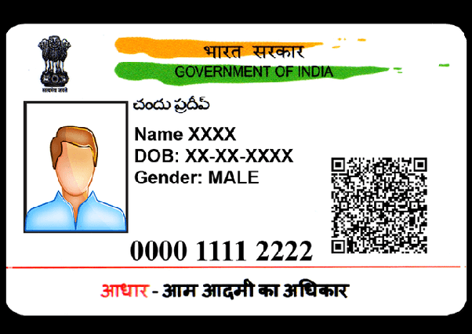



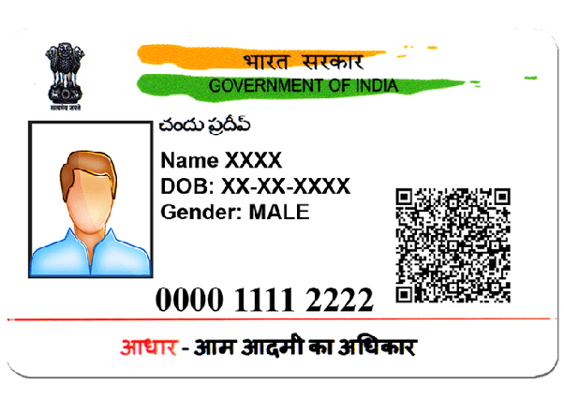 NAME = ARYA JHA

DOB = 18/08/2009

GENDER = FEMALE